**PROOF OF TESTING**

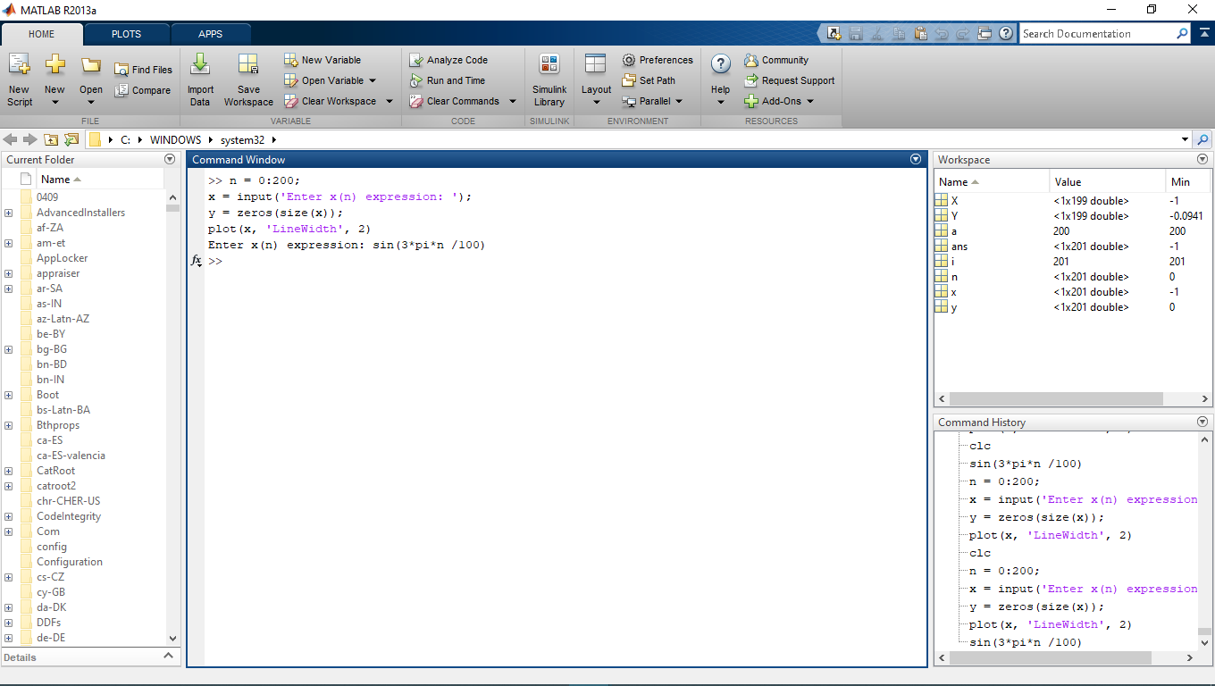**MATLAB Problem 5**

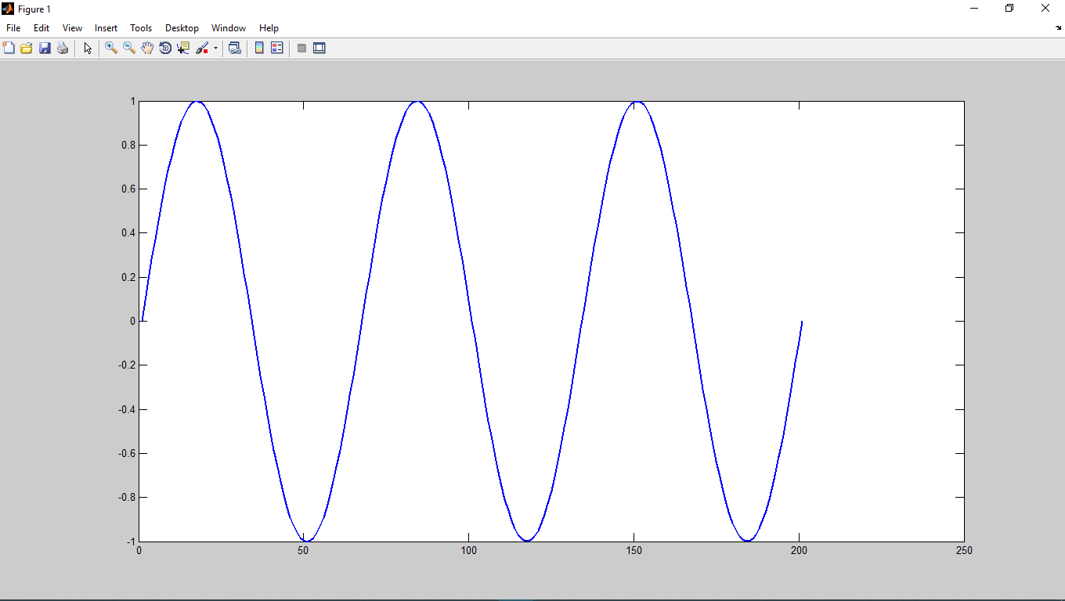

**Plot generated: x(n)**

**User input x(n)**

**Using x(n) = sin(3*pi*n /100)**

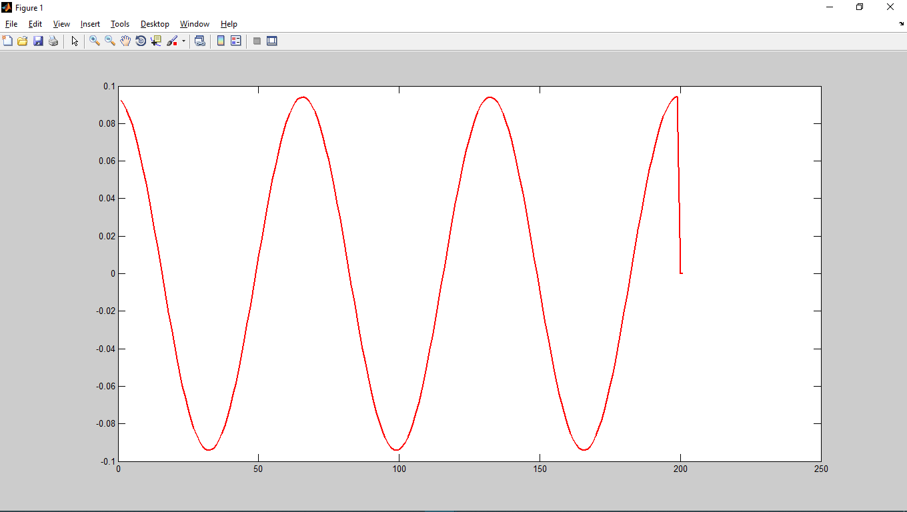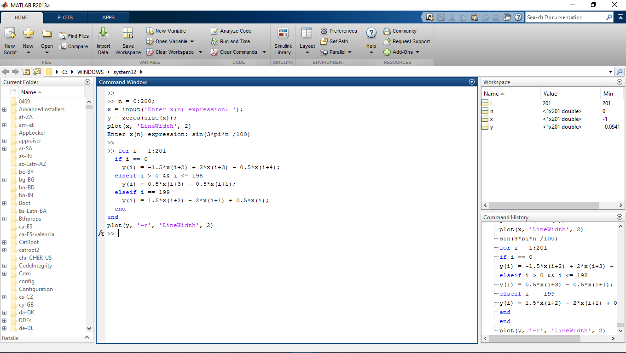

**Plot generated: y(n)**

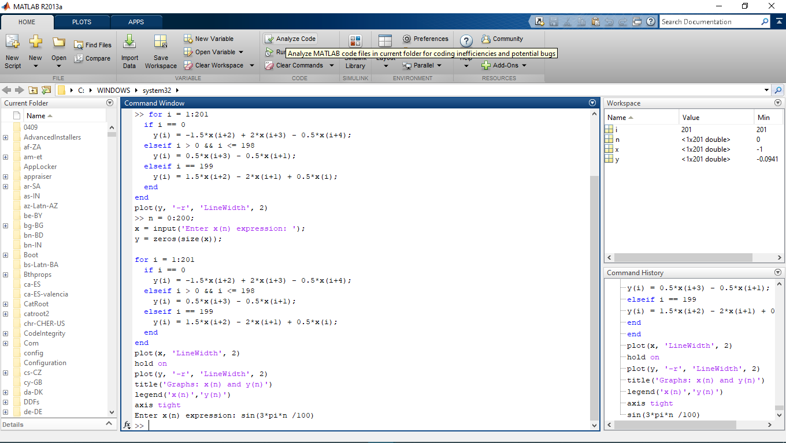

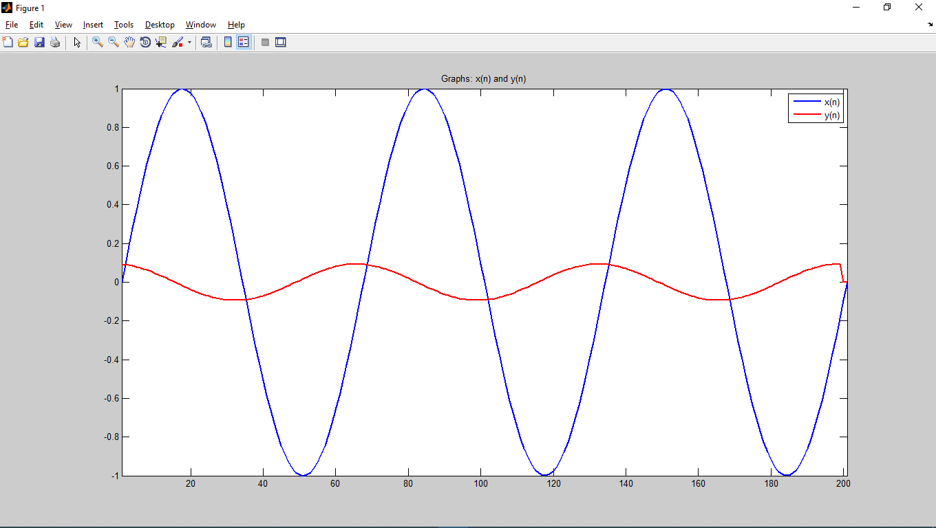

**Graph: x(n) and y(n)**